You're Changing What's Possible in Rogers County Schools
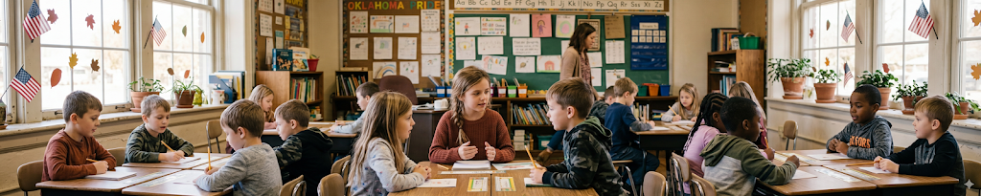
Every week, your support sends prevention specialists into classrooms across Rogers County in eight school districts. They're not there to lecture. They're there to give kids something most of them have never been formally taught: how to handle what life throws at them.
Resilience. Self-control. Empathy. The ability to pause before reacting, to name a feeling instead of exploding, to believe that their life is worth protecting.
These aren't soft skills. They're survival skills. And the data shows they're working.
71%  decrease in dysfunctional coping | 62.9%  increase in self-control | 58.1%  increase in empathy
Those numbers represent kids who used to get sent to the office and now raise their hand instead. Kids who used to shut down and now speak up. Kids who used to believe the worst about themselves - and are starting to believe something different.
"My students who receive services from RCYS are happier this year than I have ever seen them before."
TEACHER, ROOSA ELEMENTARY

IN THEIR OWN WORDS
"I am able to control myself now way more than I used to."
"This class is great. I don't think so badly of myself."
"It taught me how to deal with hard situations."
"Panic attacks no longer rule me. Because of this class, I've learned how to handle feelings of panic and stress."

When one child learns to regulate their emotions, the whole classroom changes. The teacher gets her room back. Every other student gets a better learning environment. One kid. A ripple that reaches everyone.
You did that. Every one of those voices exists because you showed up for kids you'll probably never meet.
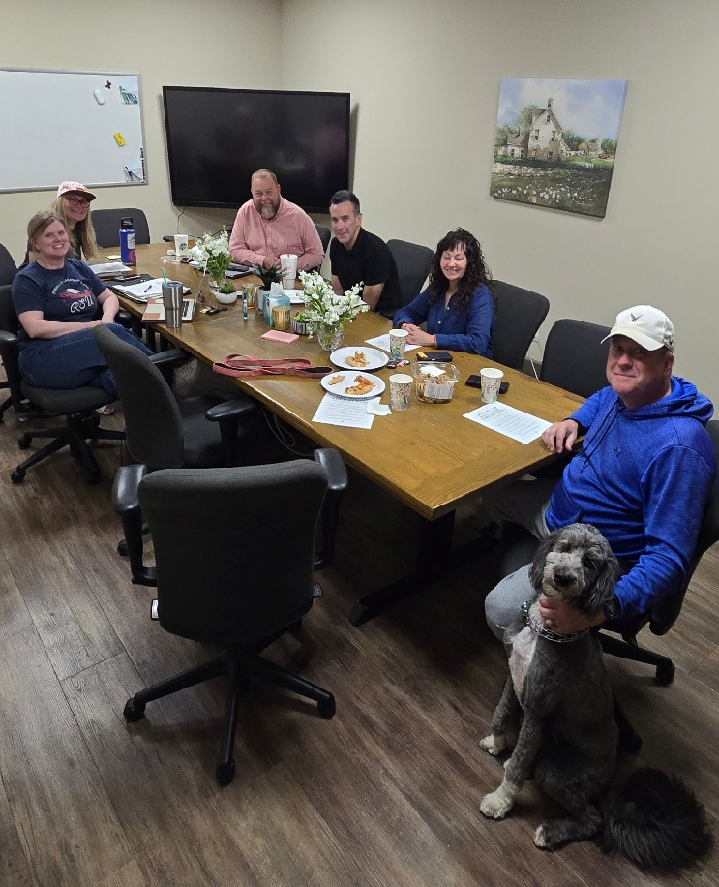
NEW INITIATIVE - CHILD ABUSE COALITION
Fighting Child Abuse in Rogers County. Together.
A few months ago, Claremore Police Chief Steve Cox reached out to us with a problem. His investigators were overwhelmed. Child abuse cases in Rogers County were outpacing their capacity to respond - and the children caught in the middle were paying the price.
I'll be honest with you: my first instinct was that this wasn't a fight we could win.
Child abuse is a deep, complicated, systemic problem. What could a small nonprofit do?
But I did the research. And I found that prevention-focused coalitions - when the right partners are at the table - can actually move the needle. So we said yes.
Rogers County Child Abuse Coalition
Children’s Advocacy Center ● Safenet Services ● Rogers State University
Claremore Police Department ● Rogers County Youth Services

NOW IN PROGRESS
Handle With Care
Imagine a kid walks into school the morning after police came to his house. He didn't sleep. He can barely hold it together. But his teacher already knows. Not the details. Just three words on a notification from Claremore PD: "Handle with care."

No stigma. No questions asked. Just a signal that something happened at that child's house last night, and they might need a little more grace today.

It costs nothing. It could change everything for a kid sitting in a classroom trying to hold it together. That's Handle with Care, and the coalition is implementing it in partnership with Claremore PD.

We're also bringing in a nationally recognized trainer later this year and exploring prevention-focused curriculum to offer in Rogers County schools next school year.

This coalition is new. The work ahead is significant. But the right people are at the table, and Rogers County's children are safer because of it. We'll keep you posted. - Herb
PREVENTION IN ACTION
What It Looks Like When It's Working
On March 6th, tornado sirens went off in Foyil.
Kids across Rogers County panicked. But with the students from classrooms where RCYS prevention specialist Rylee Shearrer had been working, something different happened.
Students started using what they had learned. Breathing. Grounding. Distress tolerance skills - practiced in the classroom, deployed when it actually mattered.
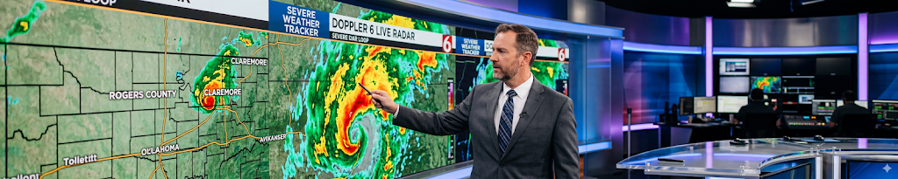

That's not a lesson plan. That's a life skill. And it showed up when the sirens went off.
It's Happening All Over Rogers County
SEQUOYAH
At Sequoyah, Lynn Partney was wrapping up an emotional regulation class when students did something unexpected. They asked to stay for a 7th hour.
They didn't want to leave. That doesn't happen by accident.

DRUG EDUCATION
Amanda Johnson teaches a drug education class for students who have failed a drug test - a way to get them back in school faster while addressing the reason they're there.
One student came in already vaping. One session. She quit.

Your support puts people like Rylee, Lynn, and Amanda in those classrooms every week. In Foyil. In Sequoyah. In Rogers County.

Thank you for believing kids are worth the investment.

BUILDING UPDATE
Progress You Can See.
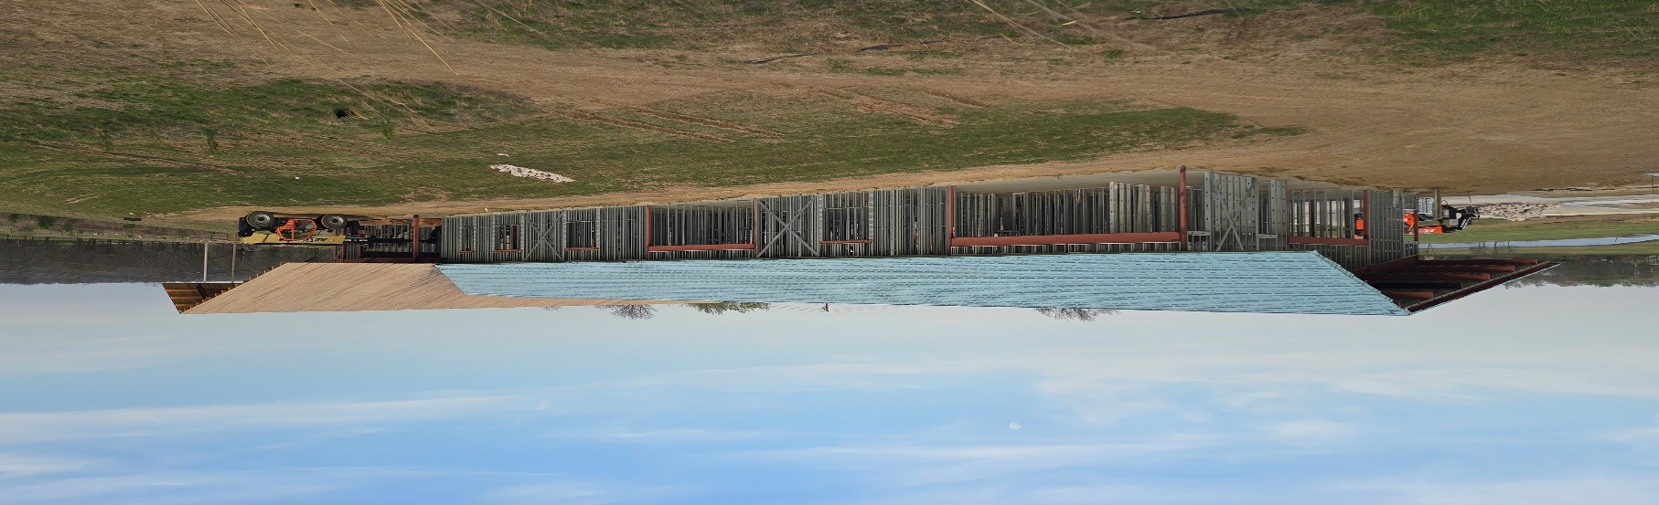
[ Construction site photo — walls going up ]

That's what your generosity looks like right now. Not finished. Not polished. But real. And rising.

Fifty years ago, someone believed Rogers County kids were worth fighting for.
That belief built this organization. It put prevention specialists in classrooms, counselors alongside struggling families, and a second chance in front of teenagers who needed one.
This building is what that belief looks like in steel and concrete. It's where the next chapter gets written - more kids, more families, more of what we've been doing for half a century.
The work that started in 1976 isn't slowing down. We're just building a bigger table.
Capital Campaign Progress | $3.6M of $5.6M
$3.6 million raised | $2 million to go

Because of donors like you, $3.6 million is already at work on this building. Another $2 million finishes it.

If you've been considering a gift to the capital campaign, come see what your investment looks like firsthand.

Schedule a Tour  Contact Herb at (918) 527-6217 or email hmcspadden@rcys.org | Learn more  www.rcys.org/capital
Believing in the potential of youth

